**What is the Relationship between Length of Sleep and Academic Performance?**

**Introduction**

Extensive research has been conducted to understand if the duration of sleep affects the academic performance of students. Most researchers believe that if a student sleeps for a long time, their mind can rest and activate itself the following day, improving their classroom engagement and participation in the next class (Tomaso et al., 253; Garcia et al., 2023). However, some researchers do not believe there is any correlation between sleep duration and academic achievement. As a biology student, I also understand that sleep plays an important role in cognitive functions including memory consolidation, attention, and problem-solving; all these elements are essential for academic success. This study, therefore, aims to understand if there is a relationship between these two variables. If there is any relationship, I would also want to understand its strength.

**Method**

The data was collected through a survey conducted online. The consent form was first shared online, and the students were supposed to tick that they had read and understood the consent form, including the objective of the study. The participants were also required to show proof of their results by attaching a screenshot of their most recent academic performance through email as well as the specific number of hours, as the survey questionnaire only represented a range.

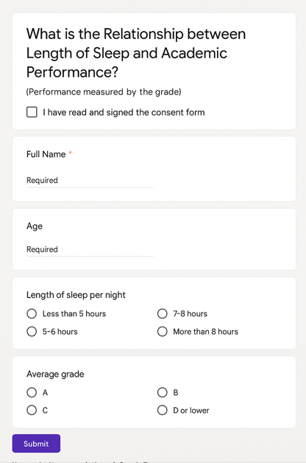

*Figure 1: Screenshot of the Survey*

I received a total of 63 responses and I sampled the responses by selecting every 2nd response until I had 30 participants that took part in the study. The study maintained anonymity at every stage and the respondents were aware that their data was taken for educational purposes only. I then converted the grades to the Grade Point Average (GPA) system.

**Results and Analysis**

*Table 1: Raw Data after Sampling*

|  |  |  |  |
| --- | --- | --- | --- |
| **Participant** | **Hours of Sleep** | **Grade Scored** | **GPA Points** |
| 1 | 5.5 | C+ | 2.3 |
| 2 | 4 | D+ | 1.3 |
| 3 | 7.5 | A | 4 |
| 4 | 6 | A- | 3.7 |
| 5 | 4.5 | C | 2 |
| 6 | 5.5 | B | 3 |
| 7 | 7 | B+ | 3.3 |
| 8 | 3.5 | B+ | 3.3 |
| 9 | 5.5 | B- | 2.7 |
| 10 | 7.5 | C | 2 |
| 11 | 7.5 | C | 2 |
| 12 | 6 | B | 3 |
| 13 | 4.5 | D+ | 1.3 |
| 14 | 4 | D+ | 1.3 |
| 15 | 6 | A- | 3.7 |
| 16 | 6 | B | 3 |
| 17 | 3.5 | D | 1 |
| 18 | 5 | B | 3 |
| 19 | 4.5 | D | 1 |
| 20 | 3 | A- | 3.7 |
| 21 | 6 | B+ | 3.3 |
| 22 | 8 | C | 2 |
| 23 | 5 | A- | 3.7 |
| 24 | 3 | D+ | 1.3 |
| 25 | 8 | A- | 3.7 |
| 26 | 4.5 | B+ | 3.3 |
| 27 | 2.5 | B+ | 3.3 |
| 28 | 8 | A | 4 |
| 29 | 7 | A- | 3.7 |
| 30 | 5 | C+ | 2.3 |

The highlighted columns in Table 1 will be used for further analysis. The first step in the analysis was to determine if there were any outliers in the data. I used a box and whiskers plot to determine if there were any data points outside the box and a whiskers plot, which I would then use IQR to identify the outliers and remove them for further analysis.

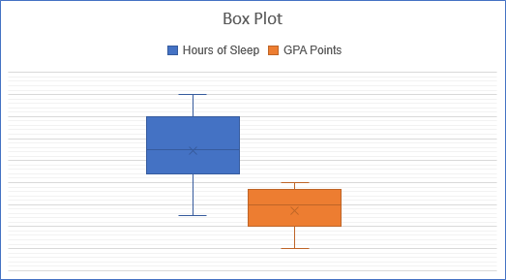

*Figure 2: Box Plot for Hours of Sleep and GPA points*

Based on Figure 2, it is evident that no data is outside the box and whisker plot indicates that both data sets do not contain any outliers.

**Independence of the Variable**

Before determining the strength of the relationship between the variables, it was important to check whether the variables were dependent on one another. Chi-square test of independence will be used to test for independence of the variables. The following hypotheses were formulated:

H0: The GPA points that a student achieves is independent of the number of hours that the student sleeps.

H1: The GPA points that a student achieves is dependent on the number of hours that the student sleeps.

*Table 2: Observed Frequencies*

|  |  |  |  |
| --- | --- | --- | --- |
|  | Below mean sleep hours | Above mean sleep hours | TOTAL |
| below mean GPA points | 10 | 0 | 10 |
| Above mean GPA points | 8 | 12 | 20 |
| TOTAL | 18 | 12 | 30 |

With the observed frequencies in Table 2, I calculated the expected frequencies as follows:

$$Expected frequency= \frac{totals in the rows×totals in the colums}{totals}$$

For example:

$$Expected frequency= \frac{18×10}{30}$$

$$Expected frequency=6 students$$

*Table 3: Expected Frequencies*

|  |  |  |  |
| --- | --- | --- | --- |
|  | below mean sleep hours | Above mean sleep hours | TOTAL |
| below mean GPA points | 6 | 4 | 10 |
| Above mean GPA points | 12 | 8 | 20 |
| TOTAL | 18 | 12 | 30 |

Since this is a 2 by 2 contingency table, the number of degrees of freedom is one, and Yate’s X2 is used to determine the calculated value of X2, which includes the 0.5 continuity correction (Portland State University).

$$X_{Yate's}^{2}= \sum{\frac{{\left({|O}_{f}-E_{f} | -0.5\right)}^{2} }{E_{f}}}$$

$$X_{Yate^{'}s}^{2}=2.04+3.06+1.02+1.53$$

$$X_{Yate^{'}s}^{2}=7.65$$

The value of X2 is 0.05, and the critical value and df 1 is 3.841 (University of Arizona). It is evident that the calculated value of X2 is larger than the value at 0.05 critical value from the chi-square distribution table. This therefore gives enough evidence to show that we have to reject the null hypothesis and accept the alternative hypothesis that suggests that the GPA points acquired by the student is dependent of the number of hours of sleep.

**Exploring the Relationship between Hours of Sleep vs GPA Points**

*Figure 3: Scatter Plot Showing the Relationship between Hours of Sleep and GPA Points*

Based on Figure 3, it is evident that the direction of the relationship is towards a direct positive relationship between the variables. It is however important to note that the coefficient of determination is given as R2 = 0.1266, indicating that a linear relationship may not be the most appropriate model that can explain the relationship between the variables. However, Pearson’s correlation coefficient was calculated and found to be $r=0.356$ indicating that the relationship between the two is moderately strong (The BMJ). Since grade A is the most coveted grade for many students, let us calculate the number of hours that a student should sleep, for them to get grade A:

$$y = 0.215x + 1.5351$$

$$4.0=0.215x+1.5351$$

$$0.215x=2.4649$$

$$x=11.5 hours$$

**Evaluation**

The strength of this study lies in the methodological rigor of the study. The study started by identifying the outliers that may have skewed the analysis before determining if the two variables were related. However, one of the limitations is that a linear model is not an appropriate model for explaining the relationship between these two variables based on its low coefficient of determination. This explains why we found 11.5 hours to be the number of hours that a student should sleep in order to get a grade A. This is quite impractical because the nature of education cannot allow one to have more than 8-10 hours of sleep.

**Conclusion**

The current paper aimed to determine the relationship between sleep duration and academic performance of students. The study has found that the relationship between the two is positive linear relationship with $r=0.356$ as the correlation coefficient indicating a moderately strong relationship between the variables. The findings of this study suggest that students who sleep longer tend to perform better academically and this can be linked back to the introduction section where I noted that sleep is a critical component of academic success. Therefore, schools, parents, and policymakers should consider integrating sleep education into health programs and adjusting academic schedules to accommodate adequate sleep.

Works Cited

The BMJ. "11. Correlation and regression." *The BMJ*, 28 Oct. 2020, www.bmj.com/about-bmj/resources-readers/publications/statistics-square-one/11-correlation-and-regression.

Garcia, Ghian L., et al. "The Relationship of Sleep Hours on the Academic Performance and Classroom Participation of Senior High School Students." *Edukasiana: Jurnal Inovasi Pendidikan*, vol. 2, no. 3, 2023, pp. 222-236.

Portland State University. "Yate's X Squared." *Portland State University*, 2020, web.pdx.edu/~newsomj/uvclass/ho_chisq.pdf.

Tomaso, Cara C., et al. "Associations between preschool sleep problems and observed dimensions of elementary classroom engagement." *Early Childhood Research Quarterly*, vol. 57, 2021, pp. 251-259.

University of Arizona. "Chi-Square Distribution Table." *University of Arizona*, 2021, math.arizona.edu/~jwatkins/chi-square-table.pdf.