**Dependence of the Terminal Velocity of a Falling Object in Relation to its Constituent Mass**

**Research Question**

What is the effect of varying the mass of a marble (0.0060, 0.0110, 0.0160, 0.0210, 0.0260 kg) on its terminal velocity when released from a fixed height into water, as analyzed through motion-tracking video software?

**Background and Theory**

When a solid object falls through a fluid like water, it is expected that the object will accelerate due to gravity. However, it is also important to note that as the velocity increases, the fluid resistance also increases until the net force on the marble becomes zero. The fluid resistance is also known as drag. Once the net force is zero, the marble falls at a constant speed known as the terminal velocity. Therefore, during its motion, the marble is subjected to gravitational force:

$$F_{g}=mg…\left(force 1\right)$$

$$F_{b}= ρ_{f}Vg.. \left(force 2;the upthrust\right)$$

$$and F_{d}=\frac{1}{2}C_{d}ρ_{f}Av^{2}…(force 3;drag force)$$

Where:

* $m$ is the mass of the marble in SI units (kg)
* $g$ is the acceleration due to gravity (9.81 m s-1)
* is the density of water in kg/m3
* is the volume of the marble in m3
* is the cross-sectional area in m2
* is the dimensionless drag coefficient
* $v$ is the velocity of the marble in m/s

But remember that at terminal velocity $v_{t}$, the net force is zero. This is to mean that:

$$F_{g}= F_{b}+F_{d}$$

Substituting the expressions will give us:

$$mg=ρ_{f}Vg+\frac{1}{2}C_{d}ρ_{f}A{v_{t}}^{2}$$

Substituting for $v_{t}^{2}$:

$$v_{t}^{2}= \frac{2g\left(m-ρ_{f}V\right)}{C_{d}ρ_{f}A}…equation 1$$

Since I will be using a spherical marble, the volume of a sphere is given by:

$$V=\frac{4}{3}πr^{3}$$

And its projected area is given by:

$$A= πr^{2}$$

When we substitute for the volume and the area into equation 1, we get:

$$v_{t}^{2}=\frac{2gm}{C_{d}ρ_{f}πr^{2}}-\frac{8grρ_{f}}{3C_{d}}…equation 2$$

When we linearize equation 2 into:

$$v_{t}^{2}=km-c$$

We will have:

* $v_{t}^{2}$ as the dependent variable
* $m$ as the independent variable and it’s the mass of the marble
* $\frac{2gm}{C_{d}ρ_{f}πr^{2}}$ as the slope of the curve
* $and \frac{8grρ_{f}}{3C_{d}}$ as the y-intercept of our curve

**Hypothesis of the Study**

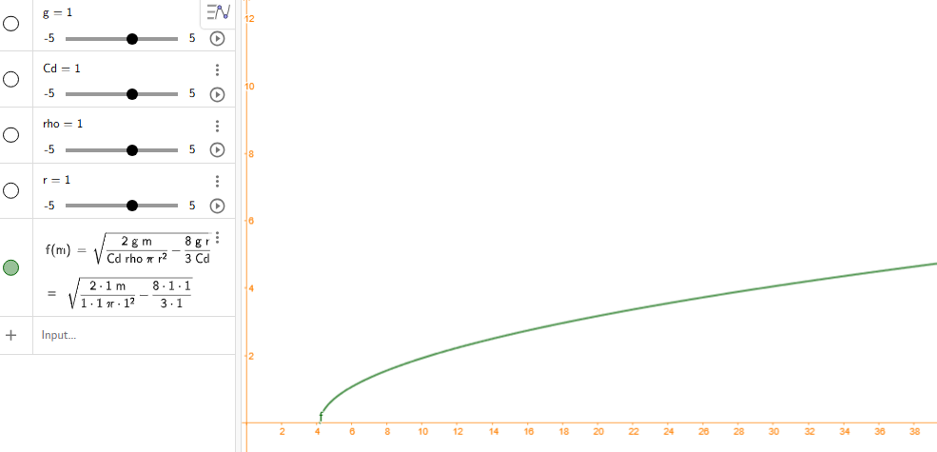

*Figure 1: Hypothetical Curve Based on Theory*

Based on the theory, I expect that the increase in mass will lead to the increase in terminal velocity of the marble with 0.0060 kg marble having the lowest terminal velocity and 0.02600 kg marble having the highest terminal velocity. I also expect that the relationship will be non-linear and this is based on equation 2 which I copy pasted to the GeoGebra graphing calculator and I found that the curve I should expect to define the relationship between the two variables is given in Figure 1.

Null Hypothesis: The terminal velocity of an object is independent of its mass

Alternative Hypothesis: The terminal velocity of an object is dependent on its mass

*Table 1: The Table of Variables*

|  |  |
| --- | --- |
| Variable Type | Variable name and method of measurement |
| Independent | Mass of the marbles which will range from 0.0060, 0.0110, 0.0160, 0.0210, 0.0260 kg) and will be measured using a weighing scale with a ±0.0001 kg absolute uncertainty. |
| Dependent | The vertical terminal velocity which will be measured by recording the fall of the marbles in water and plotting the displacement against time using a video analysis software. |
| Controlled variables | Size of the marbles, height of drop, drag coefficient, gravitational acceleration, density of water, and temperature of water. |

I was however not able to control the following variables and all these variables could, in one way or another affect the results of the studies:

* Environmental conditions
* Water conditions
* The surface conditions of the marble

**Preliminary Investigation**

Before starting this investigation, an experiment was conducted to identify if it was feasible and determine the ideal masses.

* I started with 0.0010 kg as the minimal mass of the marble but the terminal velocity was quite small which made me increase the mass to 0.0050 kg and I was able to notice a significant velocity. However, when the mass was increased to 0.0060 kg, the velocity was significant and more noticeable compared to the other masses of the marble. Therefore, I decided that this would be my most minimal mass of the marble
* Since I had noted that the mass of 0.005 kg was also noticeable, I decided that my increment would be an additional 0.0050 kg and I wanted only five masses as they would have been enough to note any changes in the terminal velocity when an object fall. Therefore, my highest mass of the marble was 0.0260 kg.

*Table 2: Equipment and their Uncertainties*

|  |  |
| --- | --- |
| Material/Equipment | Uncertainty |
| Five marbles different masses | (Based on weighing scale) |
| Measuring tape | ±0.05 m |
| Weighing scale | ±0.001 kg |
| Glass tank | - |
| Camera and tripod | - |
| laptop | - |
| Video analysis software | - |
| Thermometer | ±0.5°C |

**Experimental Procedure**

1. Set up a retort stand and attach a meter ruler using a colorless cello tape
2. Fill a glass tank to a height of 1.000 m
3. Set the camera in front of this setup as shown in Figure 2 and connect it to video analysis software on the laptop
4. Use a vernier caliper to measure the radius of the marble
5. Use a thermometer to measure the temperature of the water
6. Measure the mass of the marble using a weighing scale
7. Start the camera and simultaneously drop the marble (0.0060 kg) in water as the camera record the fall of the marble
8. Remove the marble repeat step 7 four more times
9. Repeat steps 4 to 8 for the remaining masses of the marble balls

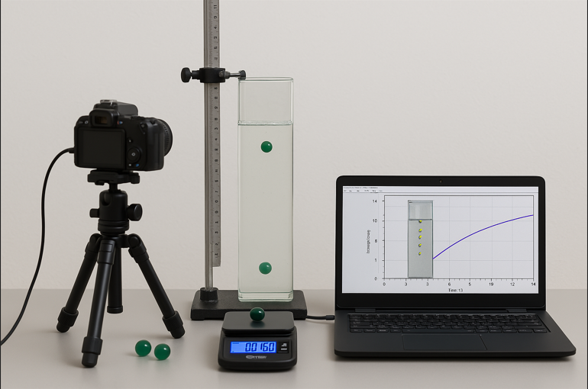

*Figure 2: Experimental Set-up*

**Results and Analysis**

**Quantitative Results**

*Table 3: Raw Data*

|  |  |  |  |  |  |
| --- | --- | --- | --- | --- | --- |
| Mass of the marble/kg ± 0.001 kg | Terminal Velocity of the Marble/vt ms-1±0.01 ms-1 | | | | |
| Trial 1 | Trial 2 | Trial 3 | Trial 4 | Trial 5 |
| 0.0060 | 0.415 | 0.420 | 0.416 | 0.417 | 0.417 |
| 0.0110 | 0.851 | 0.860 | 0.848 | 0.857 | 0.855 |
| 0.0160 | 1.310 | 1.317 | 1.321 | 1.312 | 1.315 |
| 0.0210 | 1.600 | 1.602 | 1.598 | 1.605 | 1.600 |
| 0.0260 | 1.882 | 1.890 | 1.880 | 1.888 | 1.880 |

To calculate the average terminal velocity (using mass 0.0060 kg):

$$v_{t avg}= \frac{\sum_{n=5}{n}}{N}$$

$$v_{t avg}= \frac{0.414+0.421+0.417+0.415+0.419}{5}$$

$$v_{t avg}=0.417 ms^{-1}$$

On the other hand, since five trials were made, I calculated the random error using:

$$random error= \frac{{vt}_{max}-{vt}_{min}}{2}$$

$$random error= \frac{0.420-0.415}{2}$$

*Table 4: Processed Data Table*

|  |  |  |  |  |  |  |  |  |  |
| --- | --- | --- | --- | --- | --- | --- | --- | --- | --- |
| Mass of the marble / kg (±0.0001 kg) | Average velocity | random error | uncertainty in mass | uncertainty in meter ruler | uncertainty in terminal velocity | sum of percentage uncertainties | absolute uncertainty | max y | min y |
| 0.006 | 0.417 | 0.0025 | 16.67 | 5.00 | 2.40 | 24.06 | 0.10 | 0.517 | 0.317 |
| 0.011 | 0.854 | 0.006 | 9.09 | 5.00 | 1.17 | 15.26 | 0.13 |  |  |
| 0.016 | 1.315 | 0.0055 | 6.25 | 5.00 | 0.76 | 12.01 | 0.16 |  |  |
| 0.021 | 1.601 | 0.0035 | 4.76 | 5.00 | 0.62 | 10.39 | 0.17 |  |  |
| 0.026 | 1.884 | 0.005 | 3.85 | 5.00 | 0.53 | 9.38 | 0.18 | 2.061 | 1.707 |

*Figure 3: Relationship between the Mass of the Marble and its Velocity*

**Conclusion**

The current paper aimed to explore the relationship between the mass of an object (where the marble was used in this case) and its terminal velocity when falling down through a fluid (water in this case). The hypothesis of the study was that there would be a positive non-liner relationship between the two variables. This hypothesis has been proven based on Figure 3.

**Evaluation**

The major strength of this investigation is that the investigation was able to come up with the results which are consistent with the working hypothesis of the study. However, there were a few errors such as the initial placement of the marble which was not consistent for all the marbles and this changed the drop conditions which consequently affected the velocity of the marble. This can however be improved by creating a slanting shelf towards the glass tank so that the ball is released at the same conditions.

**References**

Khan, S., Ali, S. S., Zaheer, I., Saleem, S., Ziaullah, Zaman, N., Iqbal, A., Suleman, M., Wadood, A., Rehman, A. U., Khan, A., Khan, A., & Wei, D. (2020). Proteome-wide mapping and reverse vaccinology-based B and T cell multi-epitope subunit vaccine designing for immune response reinforcement against*Porphyromonas gingivalis*. *Journal of Biomolecular Structure and Dynamics*, *40*(2), 833-847.

Martinez, L., Cords, O., Liu, Q., Acuna-Villaorduna, C., Bonnet, M., & Fox, G. (2022). Infant BCG vaccination and risk of pulmonary and extrapulmonary tuberculosis throughout the life course: a systematic review and individual participant data meta-analysis. *The Lancet Global Health*, *10*(9). <https://www.thelancet.com/journals/langlo/article/PIIS2214-109X(22)00283-2/fulltext>

Ssentongo, P., Ssentongo, A. E., Voleti, N., Groff, D., Sun, A., Ba, D. M., Nunez, J., Parent, L. J., Chinchilli, V. M., & Paules, C. I. (2022). SARS-CoV-2 vaccine effectiveness against infection, symptomatic and severe COVID-19: a systematic review and meta-analysis. *BMC Infectious Diseases*, *22*(1).

Sánchez-Ramón, S., Conejero, L., Netea, M. G., Sancho, D., Palomares, Ó., & Subiza, J. L. (2018). Trained Immunity-Based Vaccines: A New Paradigm for the Development of Broad-Spectrum Anti-infectious Formulations. *Frontiers in Immunology*, *9*(4).