Research Question: What is the effect of increasing the temperature of the solution from 25, 30, 35, 40, to 45°C on the rate of reaction of carbonic acid? What is the activation energy for this reaction?

**Background Information**

Carbonic acid (H2CO3) decomposes to give water and carbon (IV) oxide is emitted during this reaction (PASCO, 2022). The reaction of decomposition is given as follows:

$$H_{2}{CO}_{3}→H_{2}O+{CO}_{2}$$

There are various factors that influence the rate of chemical reaction above and one of the factors that affect the rate of this reaction is temperature. Generally, when the temperatures are high, the rate of collision is increased and particles can collide with each other more vigorously, causing the rate of reaction to proceed faster (Chemistry LibreTexts, 2023).

Activation energy, on the other hand, refers to the minimum amount of energy that is required for a chemical reaction to occur (Khan Academy, 2021). It is denoted by the symbol Ea and, theoretically, is derived based on the rate equation and, in this case:

$$rate of decomposition=k{\left[H_{2}{CO}_{3}\right]}^{x}$$

Making k the subject of the formula, we will have:

$$k=\frac{rate}{{\left[H_{2}{CO}_{3}\right]}^{x}}$$

And:

$$\frac{rate}{{\left[H_{2}{CO}_{3}\right]}^{x}}=Ae^{\frac{{-E}_{a}}{RT}}$$

Where:

* $R, T, and A$ are the gas constant, temperature in Kelvin, and the Arrhenius equation respectively.
* $x and k,$ on the other hand, are the order of the reaction and the rate constant respectively

Linearizing this equation will give us:

$$\ln{(rate)}=\frac{{-E}_{a}}{RT}+\ln\left(A{\left[H_{2}{CO}_{3}\right]}^{x}\right)$$

Where:

* $\ln{(rate)}$ acts as y
* $\frac{{-E}_{a}}{RT}$ acts as m
* $and \ln\left(A{\left[H_{2}{CO}_{3}\right]}^{x}\right)$ acts as the y-intercept

Therefore, the final equation can be $y=mx+c$

Hypothesis

I expect that the increase in temperature will subsequently lead to a faster rate of decomposition of carbonic acid based on the information provided in the theory.

**Methodology**

**Variables**

*Table 1: The Table of Variables*

|  |  |  |
| --- | --- | --- |
| **Variable Type** | **Variable Name** | **Method of Measurement** |
| Independent | The temperature was the variable that was manipulated in this experiment and this was mainly because chemically we understand that the equilibrium constant is always changing with the change in temperature. Therefore, it was important to learn how this affects the rate of reaction of carbonic acid. | A water bath was used to regulate the temperature and change it from 25, 30, 35, 40, to 45°C. It is however important to note that these temperatures were later converted into Kelvin to align with the Arrhenius equation. |
| Dependent | The rate of reaction of carbonic acid was measured based on the amount of carbon (IV) oxide that was produced at every temperature. | A stopwatch was started immediately the reaction started and was stepped immediately I was able to collect 5cm3 of the gas. |
| Controlled variables | Concentration of carbonic acid (assumption of similarity in the concentration since all the carbonic acid that was used was from soda water from Schweppes), the volume of the acid used (10 cm3 measured using a 10 cm3 graduated pipette), amount of time taken while the soda is resting before using it (5 seconds), cross-sectional area of the container (similar boiling tubes were used for the experiment), the container in which the solution is heated (all the trials were conducted using test tubes), and the level at which all the tubes were immersed during heating (same level of immersion in the water bath). | |

**Apparatus and Materials**

1. Distilled water
2. Boiling tubes
3. Boiling tube stoppers
4. Rubber tubing
5. 50 cm3 burette/±0.5cm3
6. Plastic water bath
7. 320 cm3 Schweppes club soda
8. Temperature controlled water bath/±0.5°C
9. Stopwatch/±1s

**Experimental Procedure**

1. Prepare 25 boiling tubes and their stoppers by cleaning them and drying them
2. Open the soda can and wait for 10 seconds for any outburst of CO2 to leave the drink
3. Use a graduated pipette to measure 10 cm3 of the soda and use it to fill every boiling tube as you immediately seal them with the boiling tube stoppers
4. Place 5 of the sealed boiling tubes with soda into a temperature-controlled water bath and set the water bath at 25°C. Ensure the water level covers the same portion of each tube to maintain consistent heating.
5. Allow the boiling tubes to equilibrate in the water bath for 5 minutes to ensure the soda reaches the target temperature.
6. After equilibration, quickly remove one boiling tube and connect the rubber tubing to an inverted, water-filled burette submerged in a water trough to collect the gas evolved.
7. Start the stopwatch immediately as the tube is connected and gas collection begins.
8. Record the time taken to collect 5 cm³ of carbon dioxide gas in the burette.
9. Repeat steps 6–8 for each of the remaining 4 boiling tubes at 25°C.
10. Repeat steps 4–9 for water bath temperatures of 30°C, 35°C, 40°C, and 45°C, ensuring five boiling tubes are tested at each temperature.

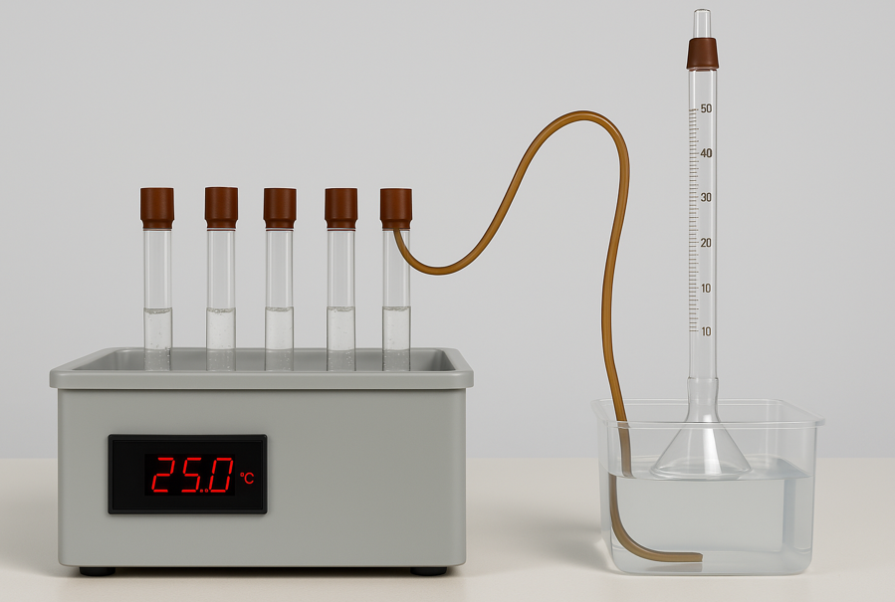

**Temperature-controlled water bath**

**5 boiling tubes filled with 10cm3 of soda**

**Rubber tube**

**Inverted 50cm3 burette**

**Plastic water bath**

*Figure 1: Annotated Experimental Setup*

**Safety, Environmental, and Ethical Considerations**

1. Exposure to high concentrations of carbonic acid is irritative to the eyes and the trachea, therefore ensure you have PPEs when conducting the experiment.
2. There were no ethical considerations.
3. There were no extreme environmental issues of concern to consider; however, the soda cans used were recycled to prevent pollution.

**Results**

**Qualitative Data**

1. I observed bubbles rapidly forming and escaping from the soda solution immediately after the boiling tube was placed in the water bath, indicating the release of carbon dioxide gas.
2. I heard a faint fizzing sound coming from the soda solution during the reaction, especially at higher temperatures.
3. I felt the stopper become slightly pressurized as the gas accumulated quickly inside the boiling tube during heating.

**Quantitative Data**

*Table 2: Raw Data (Note that temperature was converted to Kelvins by adding 273)*

|  |  |  |  |  |  |  |
| --- | --- | --- | --- | --- | --- | --- |
| Temperature | | Time Taken to Produce 5 cm3 of CO2/s±1s | | | | |
| Temperature/°C±0.5°C | Temperature/K±0.5K | Trial 1 | Trial 2 | Trial 3 | Trial 4 | Trial 5 |
| 25 | 298 | 210 | 214 | 208 | 216 | 212 |
| 30 | 303 | 145 | 147 | 149 | 143 | 148 |
| 35 | 308 | 109 | 104 | 108 | 106 | 110 |
| 40 | 313 | 72 | 70 | 75 | 71 | 74 |
| 45 | 318 | 37 | 35 | 40 | 38 | 36 |

*Table 3: Processed Data Table with Uncertainties*

|  |  |  |  |  |  |  |  |  |  |
| --- | --- | --- | --- | --- | --- | --- | --- | --- | --- |
| Temperature/K±0.5K | Average Time Taken to Produce 5 cm3 of CO2/s±1s | Random error | rate of reaction | uncertainty in temp | uncertainty in time | uncertainty in equilibrating time | uncertainty in 5cm^3 gas | total uncertainty | absolute uncertainty in the average rate of reaction |
| 298 | 212 | 4.00 | 0.024 | 0.168 | 0.472 | 0.333 | 10 | 10.973 | 0.0026 |
| 303 | 146.4 | 3.00 | 0.034 | 0.165 | 0.683 | 0.333 | 10 | 11.181 | 0.0038 |
| 308 | 107.4 | 3.00 | 0.047 | 0.162 | 0.931 | 0.333 | 10 | 11.427 | 0.0053 |
| 313 | 72.4 | 2.50 | 0.069 | 0.160 | 1.381 | 0.333 | 10 | 11.874 | 0.0082 |
| 318 | 37.2 | 2.50 | 0.134 | 0.157 | 2.688 | 0.333 | 10 | 13.179 | 0.0177 |

**Analysis**

*Figure 2: Relationship between Temperature and the Rate of Reaction*

It was then important to develop a linearized graph for the relationship between the inverse of temperature and the natural logarithm of rate:

*Table 4: 1/T vs ln rate*

|  |  |  |
| --- | --- | --- |
| **1/T** | **ln (rate)** | **uncertainty in ln rate** |
| 0.003356 | -3.74715 | 0.259 |
| 0.003300 | -3.3769 | 0.383 |
| 0.003247 | -3.06712 | 0.532 |
| 0.003195 | -2.67277 | 0.410 |
| 0.003145 | -2.00687 | 0.177 |

*Figure 3: Relationship between the inverse of temperature and ln rate*

From the linearized Arrhenius equation that we had in the background:

$$\ln{(rate)}=\frac{{-E}_{a}}{RT}+\ln\left(A{\left[H_{2}{CO}_{3}\right]}^{x}\right)$$

Therefore:

$$\frac{{-E}_{a}}{R}=gradient$$

From our linearized equation we have:

$$y = -7908.9x + 22.718$$

$$\frac{{-E}_{a}}{-8.314}=-7908.9$$

$$E_{a}=65,755J mol^{-1}$$

$$E_{a}=65.76 kJ mol^{-1}$$

**Conclusion**

The current paper aimed to determine the effect of increasing temperature on the rate of decomposition of carbonic acid. The study expected to find a positive relationship between the variables which was proven based on Figure 2 where we can see that the rate of decomposition was lowest at 298K and it was highest at 318K. Further, the study found the activation energy for thi8s reaction to be 65.76 kJ mol-1.

**Evaluation**

1. **Limitation:** Some CO₂ gas may have escaped due to poor sealing.  
   **Improvement:** Use airtight rubber stoppers and ensure tubing is tightly connected.
2. **Limitation:** The soda may have lost some CO₂ during setup.  
   **Improvement:** Reduce the time between opening the soda and sealing the tubes.

**References**

Chemistry LibreTexts. (2023, February 13). *6.1.6: The collision theory*. Retrieved April 8, 2025, from <https://chem.libretexts.org/Bookshelves/Physical_and_Theoretical_Chemistry_Textbook_Maps/Supplemental_Modules_(Physical_and_Theoretical_Chemistry)/Kinetics/06%3A_Modeling_Reaction_Kinetics/6.01%3A_Collision_Theory/6.1.06%3A_The_Collision_Theory>

Khan Academy. (2021). *Khan Academy*. Retrieved April 8, 2025, from <https://www.khanacademy.org/science/biology/energy-and-enzymes/introduction-to-enzymes/a/activation-energy>

PASCO. (2022). *Decomposition reactions - Essential chemistry | PASCO*. PASCO scientific | Science Lab Equipment and Teacher Resources. Retrieved April 8, 2025, from [https://www.pasco.com/curriculum/essential-chemistry/BookInd-2112#](https://www.pasco.com/curriculum/essential-chemistry/BookInd-2112)